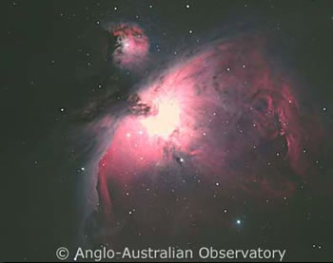
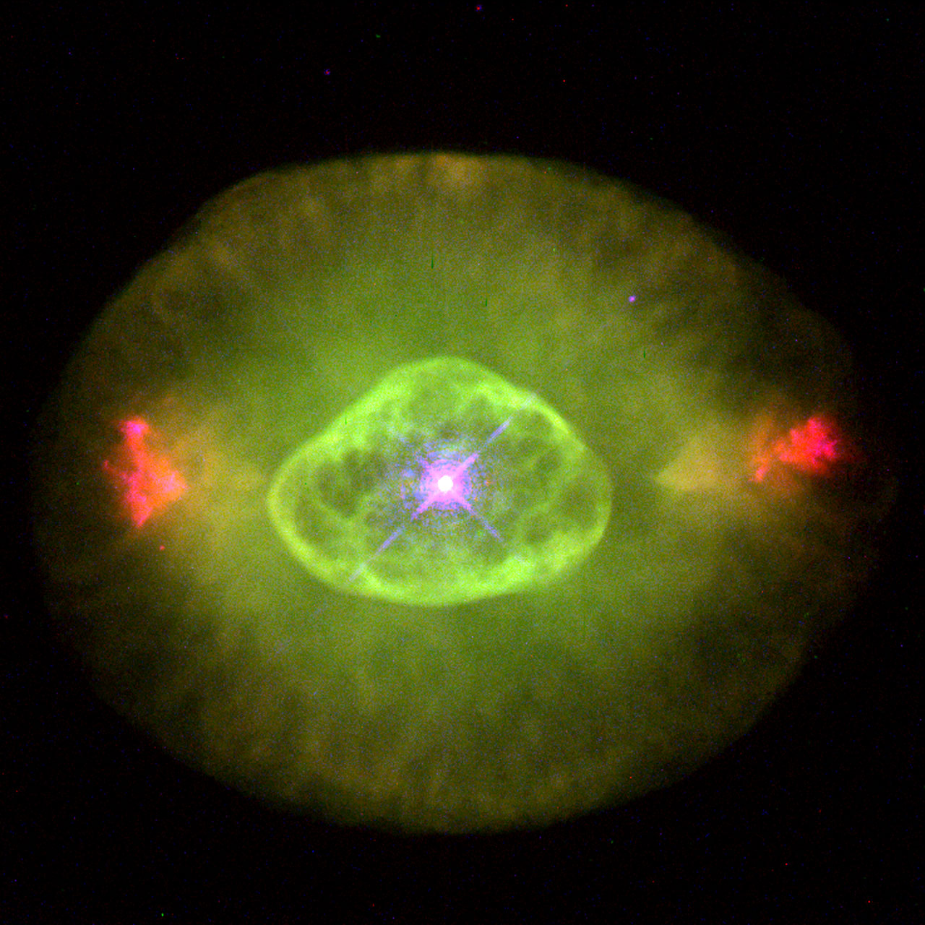

Note: Professor Matthew Malkan will discuss this research at an AAS press conference Saturday, Jan. 7 at 10:15 am CST.

The Universe Going Green

Detecting the intense green glow from the youngest galaxies offers our best opportunity for learning how the first galaxies evolved

Galaxies in the young universe were forming stars at 10-to-50 times higher rates than their modern-day counterparts, such as our Milky Way. A recent study has found that they were not merely scaled up versions of star-forming regions seen today. Instead, UCLA Professor Matthew Malkan and several collaborators have found that the earliest galaxies were “going green.” “The discovery that young galaxies are so unexpectedly bright--if you look for this distinctive green light--will dramatically change and improve the way that we study Galaxy formation throughout the history of the Universe,” Malkan said.

The astronomers discovered a startling number of distant galaxies in which the strongest emission line is from doubly ionized oxygen. Its wavelength in the green region of the electromagnetic spectrum makes the striking color that is also seen in so-called “planetary” nebulae (misnamed because their greenish color resembles that of planets Uranus and Neptune, but for completely different reasons).

This was surprising because current star-forming regions, like the nearby Orion nebula (left hand image), give a pinkish glow, which comes from atoms of hydrogen — by far the most abundant element in the universe. Newly born stars are embedded in the gas clouds out of which they were recently born. Ultraviolet photons from those young stars irradiate the atoms in the gas, causing them to heat up and lose electrons — a process called photo-ionization. This hot ionized gas then emits a distinctive pattern of colors of light. The strongest color is nearly always the pink light of heated hydrogen atoms.

But something unusual was going on in the early generations of star formation, only one or two billion years after the Big Bang. The oxygen atoms in their surrounding gas clouds have lost two electrons, rather than the usual one. Knocking off that second electron requires a lot of energy. This can be done by only extremely energetic photons (almost into the X-ray range). Few such high-energy photons are produced by the young stars seen today in Orion or anywhere else in the Milky Way or other modern galaxies.

They ARE produced by a few much hotter stars such as those found briefly in the centers of “planetary” nebula (right hand photograph above). But such extreme conditions are only seen galaxy-wide in less than one hundredth of one percent of galaxies today. Dubbed ‘green peas’, these greenish dwarf starburst galaxies were discovered by the Galaxy Zoo project. The explanation for why the young universe was going green—but then stopped--is still under intensive investigation. Malkan and colleagues suspect it is because young stars were hotter in the earlier phases of galaxy evolution. More of them effectively resembled the very hot (T>50,000º C) central stars in planetary nebulae (but with very different origins).

A recent analysis of many thousands of distant galaxies in the Subaru Deep Field with graduate student Daniel Cohen found that ALL small galaxies are surprisingly strong emitters of the green emission line of doubly ionized oxygen. By averaging data for such a large number of galaxies, they obtained the first accurate measurements of the dwarf galaxies which are extremely faint, but by far the most common in the young universe. The figure below shows an average of 1,294 of these galaxies at a redshift of z=3. These are observed two billion years after the Big Bang, when the universe was 70 times denser than today. “The O++ emission line (which falls between the two vertical dashed lines) is so strong that it even distorts the entire infrared portion of the galaxy spectrum, which is otherwise starlight,” Malkan said.
Luminosity
Observed Wavelength
The coming generation of space telescopes for cosmological surveys will soon be going for this green. In particular, the launch of NASA's James Webb Space Telescope in 2018, followed by their WFIRST in 2024, and the 2020 precursor from European Space Agency, EUCLID, are all designed to survey galaxies in the young universe though this green O++ emission line.

At the high redshifts of interest, seen in the first 500 million years since the Big Bang, this ‘green’ line is shifted even further into the infrared wavelength range, Malkan said. The cold, dark environment of these telescopes, and their new detectors, are highly optimized to provide unprecedented spectroscopic sensitivity to the strong O++ emission at these infrared wavelengths.

“This one line will be the single most powerful probe of galaxy formation, as soon as galaxies form their first stars and supernovae to produce oxygen atoms,” Malkan said. “Detecting and studying the intense green glow from the youngest galaxies (shifted into the infrared) now looks like our best opportunity for learning how the first galaxies evolved.”

This text is available on www.astro.ucla.edu/~malkan/

